- \Operation\Tube filling\Process values
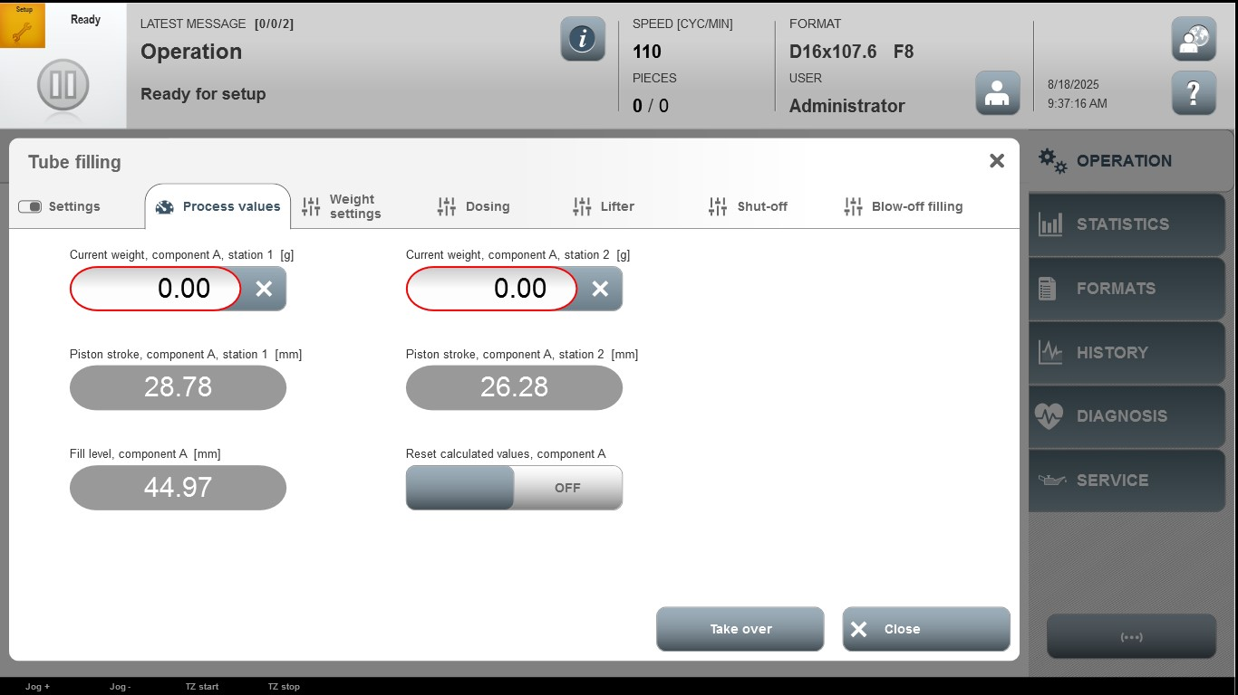

Acceptance criterion | Limits | Pass / Fail: Dev-No. | Date | Initials
Screen matches screenshot | N / A
Current weight, component A, station 1 [g] | Depending of format
Current weight, component A, station 2 [g] | Depending of format

